1

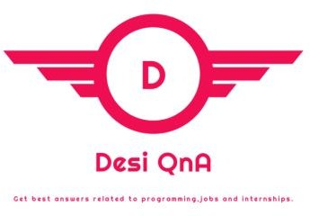

Letter of Completion of Internship

3rd August, 2023

**TO WHOMSOEVER IT MAY CONCERN**

This is to certify that “**Vibhum Ranjan Dixit”**, student of “**GL Bajaj Institute of Technology and Management**” undergoing Masters in “**Computer Application**” has successfully completed his internship at **DesiQna** as a **“Web Development Intern”** from **May 1st to July 30th 2023** under Mr. Karan Kumar, Founder at DesiQna.

During his internship at DesiQna, we found him to be sincere, hardworking and resourceful.

We wish him success in his future endeavors.

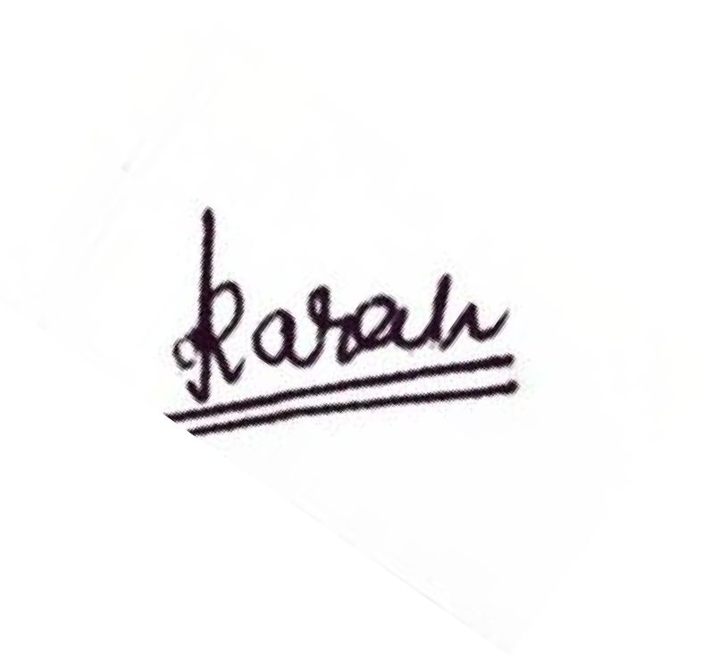

Regards,

Karan Kumar

Founder, DesiQna

DesiQna | [www.desiqna.in](http://www.desiqna.in/) | https://[www.linkedin.com/company/desiqna/](http://www.linkedin.com/company/desiqna/) | +91-88793 55057